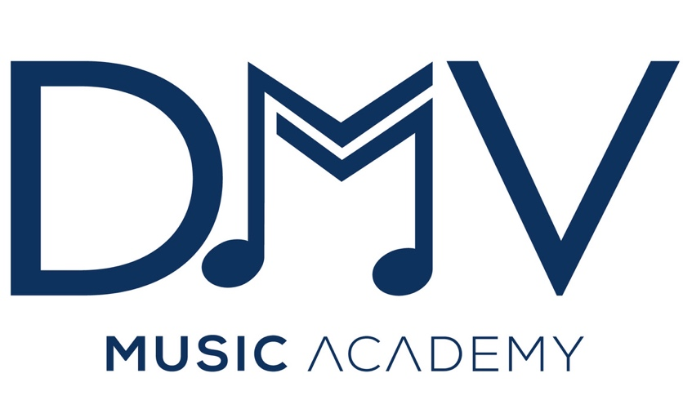
2023 Prep Workshop

March 18th 10am to 2pm

The Shed DMV, 5650 Rivertech Court, Suite Q, Riverdale, MD 20737

SCHEDULE

10am - Welcome and Kuru Mindfulness

10:30am - Audition Prep Workshop
(keys to audition success, how to audition, psychology behind performances/auditioning)

11:30am - Breakouts for students to play prepared materials

12:45pm - Break

1pm – 2pm Faculty Performances
- QuintEssential Wind Quintet
- Lyric Brass Quintet

2pm Event Ends

